Project File Structure

These are the required steps to build Mad Libs generator python project:

* Import modules
* Create a display window
* Define functions
* Create buttons

1. Import Modules

from tkinter import *

The first step to build a project is to import the required modules. In this project, we import tkinter module.

2. Create a Display Window

root = Tk()

root.geometry('300x300')

root.title('DataFlair-Mad Libs Generator')

Label(root, text= 'Mad Libs Generator \n Have Fun!' , font = 'arial 20 bold').pack()

Label(root, text = 'Click Any One :', font = 'arial 15 bold').place(x=40, y=80)

* **Tk()** initialized tkinter which means window created
* **geometry()** used when we want to set the width and height of the window
* **title()** used to give the title of the window
* **Label()** widget use to display text that users can’t able to modify
* **root** is the name which we give to our window
* **text** takes the text we want to display on the label
* **font** used to set the size and type of fonts
* **pack** organized widget in block
* **place()** used when we want to place widgets in a specific position

3. Define Function

def madlib1():

animals= input('enter a animal name : ')

profession = input('enter a profession name: ')

cloth = input('enter a piece of cloth name: ')

things = input('enter a thing name: ')

name= input('enter a name: ')

place = input('enter a place name: ')

verb = input('enter a verb in ing form: ')

food = input('food name: ')

print('say ' + food + ', the photographer said as the camera flashed! ' + name + ' and I had gone to ' + place +' to get our photos taken on my birthday. The first photo we really wanted was a picture of us dressed as ' + animals + ' pretending to be a ' + profession + '. when we saw the second photo, it was exactly what I wanted. We both looked like ' + things + ' wearing ' + cloth + ' and ' + verb + ' --exactly what I had in mind')

**def** madlib2():

adjactive = input('enter adjective : ')

color = input('enter a color name : ')

thing = input('enter a thing name :')

place = input('enter a place name : ')

person= input('enter a person name : ')

adjactive1 = input('enter a adjactive : ')

insect= input('enter a insect name : ')

food = input('enter a food name : ')

verb = input('enter a verb name : ')

print('Last night I dreamed I was a ' +adjactive+ ' butterfly with ' + color+ ' splocthes that looked like '+thing+ ' .I flew to ' + place+ ' with my bestfriend and '+person+ ' who was a '+adjactive1+ ' ' +insect +' .We ate some ' +food+ ' when we got there and then decided to '+verb+ ' and the dream ended when I said-- lets ' +verb+ '.')

**def** madlib3():

person = input('enter person name: ')

color = input('enter color : ')

foods = input('enter food name : ')

adjective = input('enter aa adjective name: ')

thing = input('enter a thing name : ')

place = input('enter place : ')

verb = input('enter verb : ')

adverb = input('enter adverb : ')

food = input('enter food name: ')

things = input('enter a thing name : ')

print('Today we picked apple from '+person+ "'s Orchard. I had no idea there were so many different varieties of apples. I ate " +color+ ' apples straight off the tree that tested like '+foods+ '. Then there was a '+adjective+ ' apple that looked like a ' + thing + '.When our bag were full, we went on a free hay ride to '+place+ ' and back. It ended at a hay pile where we got to ' +verb+ ' ' +adverb+ '. I can hardly wait to get home and cook with the apples. We are going to make appple '+food+ ' and '+things+' pies!.')

* **input(**) field takes the input from the user
* **print()** will print the text given in it.

4. Define Buttons

Button(root, text= 'The Photographer', font ='arial 15', command= madlib1, bg = 'ghost white').place(x=60, y=120)

Button(root, text= 'apple and apple', font ='arial 15', command = madlib3 , bg = 'ghost white').place(x=70, y=180)

Button(root, text= 'The Butterfly', font ='arial 15', command = madlib2, bg = 'ghost white').place(x=80, y=240)

root.mainloop()

**Button()** widget used to display buttons on our tkinter window

command is called when the button is click and it is used to call the function

**root.mainloop()** used when we want to run our program

#### Mad Libs Generator Game Output

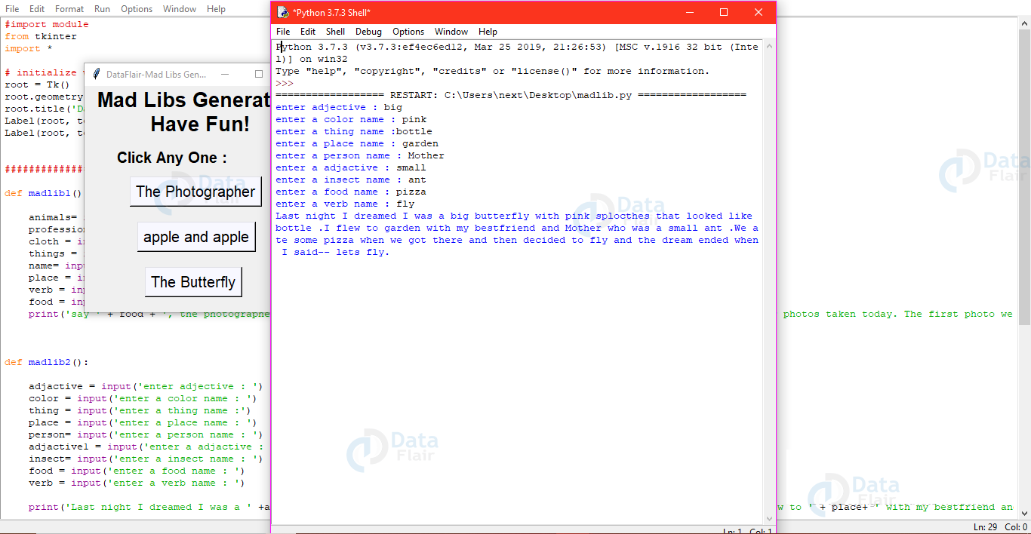

## **Summary**

We have successfully developed the mad libs generator python project. We used tkinter library for rendering graphics on a display window and learn how to create buttons widget and pass the function to the button. In this way, we build this python project.